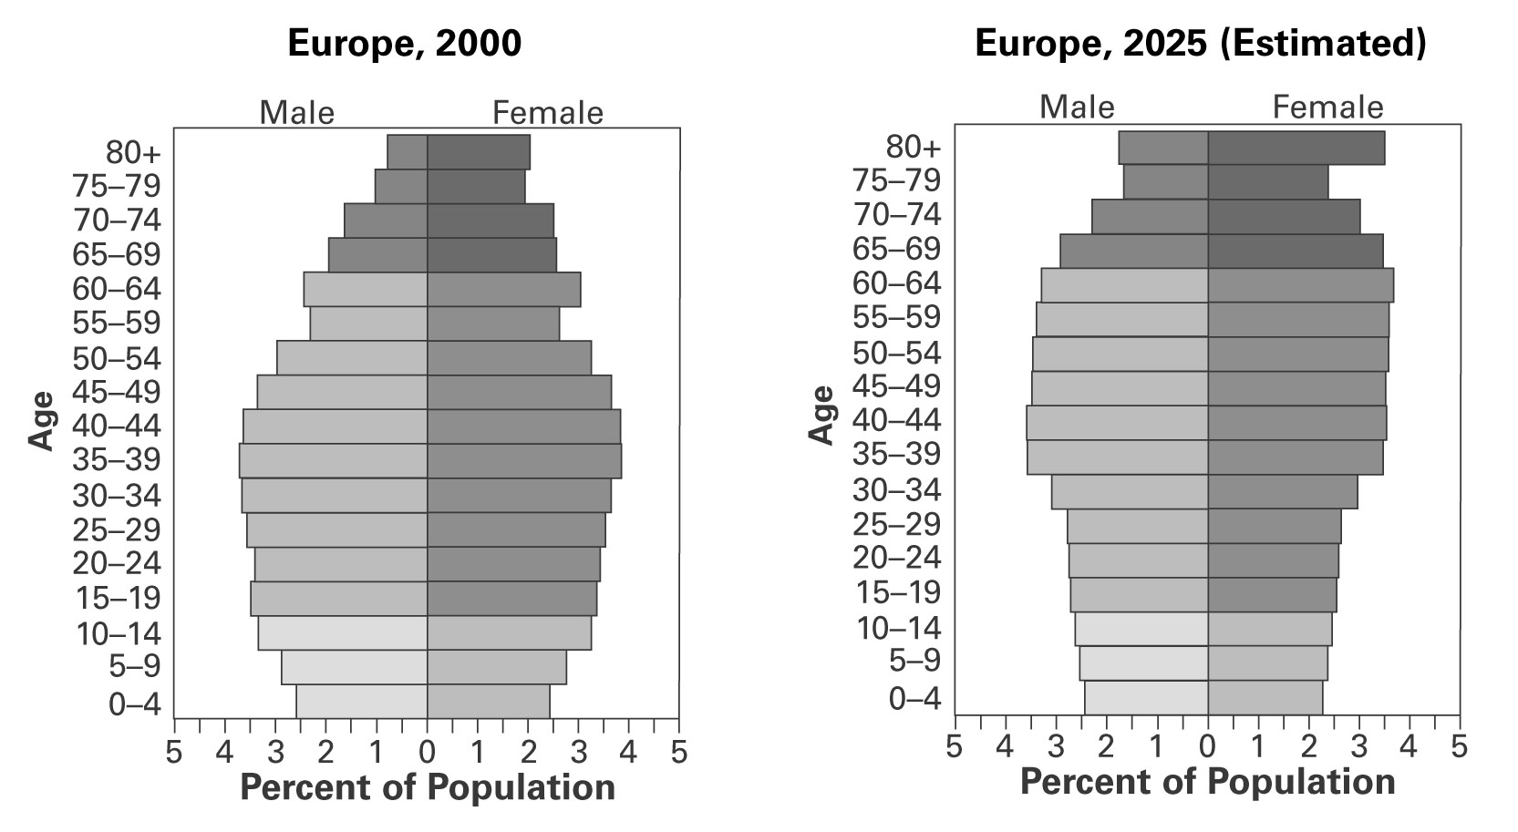
- According to the population pyramids above, between 2000 and 2025-
A. The population of Europe will decline by 10 million.
B. The population of the Europe will increase by 10 million.
C. The number of females living 80 or more years will increase.
D. The number of people living 80 or more years will decrease.
E. None of the above

